/\*\*\*\*\*\*\*\*\*\*\*\*\*\*\*\*\*\*\*\*\*\*\*\*\*\*\*\*\*\*\*\*\*\*\*\*\*\*\*\*\*\*\*

\* Programming excercise 73004 \*

\* Maxwell Stephens \*

\* 12:30 TTh \*

\* 73004, 3/23/17 \*

\*\*\*\*\*\*\*\*\*\*\*\*\*\*\*\*\*\*\*\*\*\*\*\*\*\*\*\*\*\*\*\*\*\*\*\*\*\*\*\*\*\*\*/

/\*

This program calculates the mpg of a car taking in liters and miles traveled

\*/

//define constant

const double LITERSINGALLONS = 0.264179;

//function declaration

double mpgFunc(double liters, double miles);

int main() {

//define vars

double liters = 0,

miles = 0,

mpg = 0;

char answer;

bool looping = true;

//loop

while (looping == true) {

//heading

cout << "\*\*\*\*\*\*\*\*MAX'S MPG-O-MATIC\*\*\*\*\*\*\*\*" << endl << endl << endl;

//ask for liters

cout << "Please enter the number of liters of gasoline consumed by your vehicle\n";

//take in liters

cin >> liters;

//ask for miles

cout << "Please enter the number of miles traveled on the gas used\n";

//take in miles

cin >> miles;

//call function mpgFunc and print it to the user

cout << mpgFunc(liters, miles) << " Miles per Gallon" << endl;

//read in y/n

cout << "Do another calculation? Y/N" << endl;

cin >> answer;

//exit loop using bool looping

if (answer == 'y' || answer == 'Y') {

looping == true;

}

else {

looping == false;

return 0;

}

}//end of loop

system("pause");

return 0;

}

double mpgFunc(double liters, double miles) {

double result;

result = miles / (0.264179\*liters);

return result;

}

/\*

SAMPLE OUTPUT:

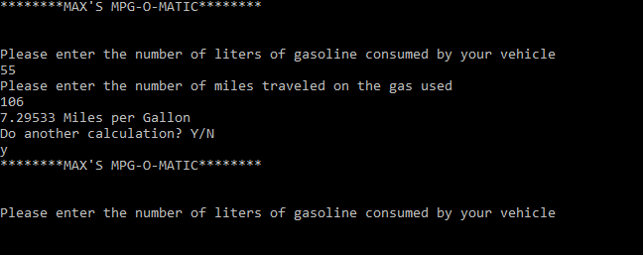

Self-Evaluation:

4: Works perfectly, code properly documented

I believe I earned 4 points.

\*/